**H Bridge**

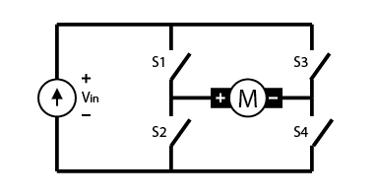

An H-bridge is built of four switches that control the flow of current to a load. In the image above, the load is the M connecting the two sets of switches. Using one current source, you can drive current in two directions by closing two switches.

|  |  |
| --- | --- |
| If Switch 1 and 4 are closed, then the current will flow from the left to right:  The H-bridge configured to have switch 1 and switch 4 closed. | If Switch 1 and 4 and closed, the current will flow from the source, through 1, to the load, through 4, and then back.  An H-bridge circuit with S2 and S3 closed. |

if the control signals to the MOSFETs overlap, the transistors will effectively short-circuit the supply causing the MOSFETs to blow up. This is called shoot-through.

To avoid this, we introduce a delay in which all the FETs are open. That 100ns to 5μs delay is called deadtime.

Unipolar and Bipolar Drive

|  |  |
| --- | --- |
| Biipolar      When there is change in current, it induces flyback votage flipping the polarity across the motor and that flows back through the bodyguard of the same MOSFET it came from.  This is why voltage across the motor terminals goes from +Vdc to -Vdc, therefore it is known as Bipolar Drive. | Unipolar      In this method, one MOSFET is kept on throughout and the other is controlled. The flyback voltage flowing back through the bodyguard of the same MOSFET is zero.  The voltage across the motor terminals here goes from +Vdc /-Vdc to 0, therefore it is known as Unipolar Drive. |